Click on Create Project

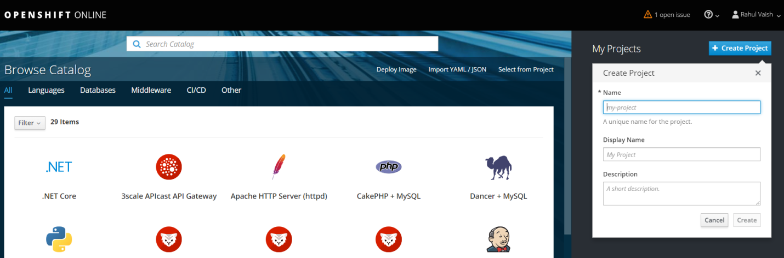

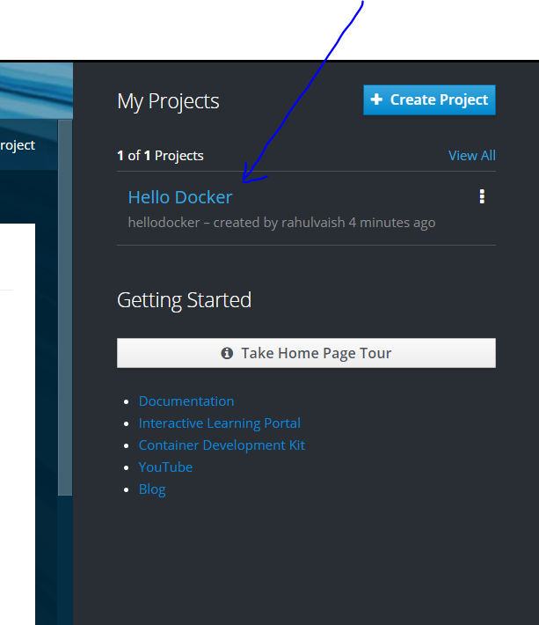

Click on Hello Docker Project, the below screen appears-

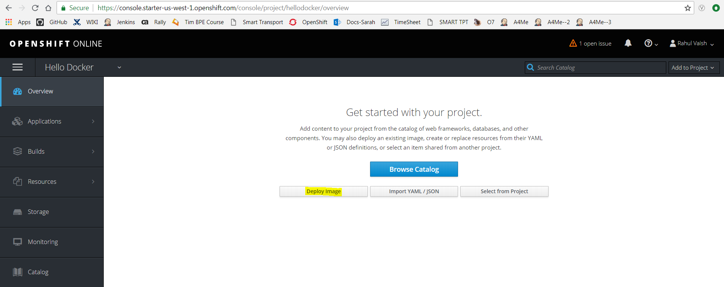

When above screen opens, click on “Deploy Image” button, the below screen appears –

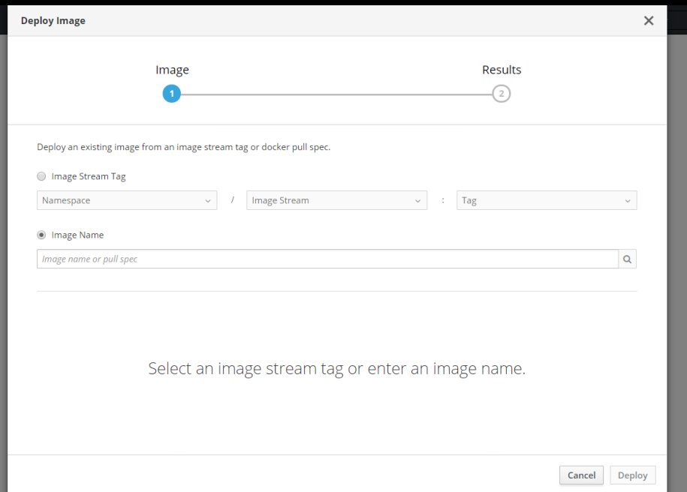

To get the image name, open **hub.docker.com**, copy the highlighted part and paste it in the above Image Name field and hit enter.

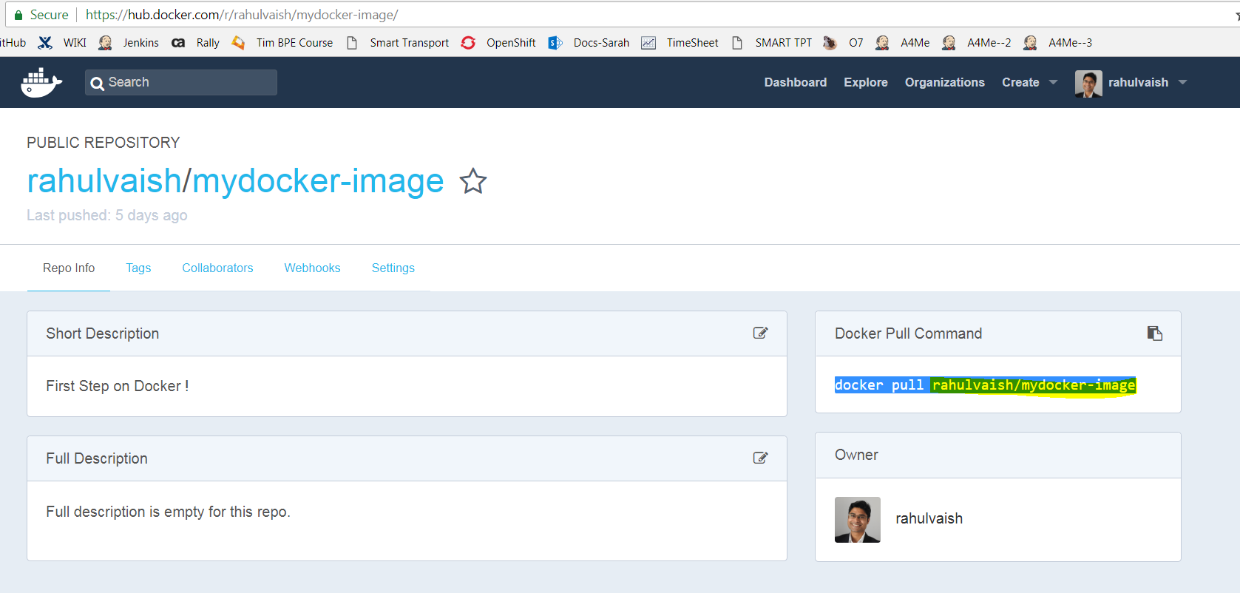

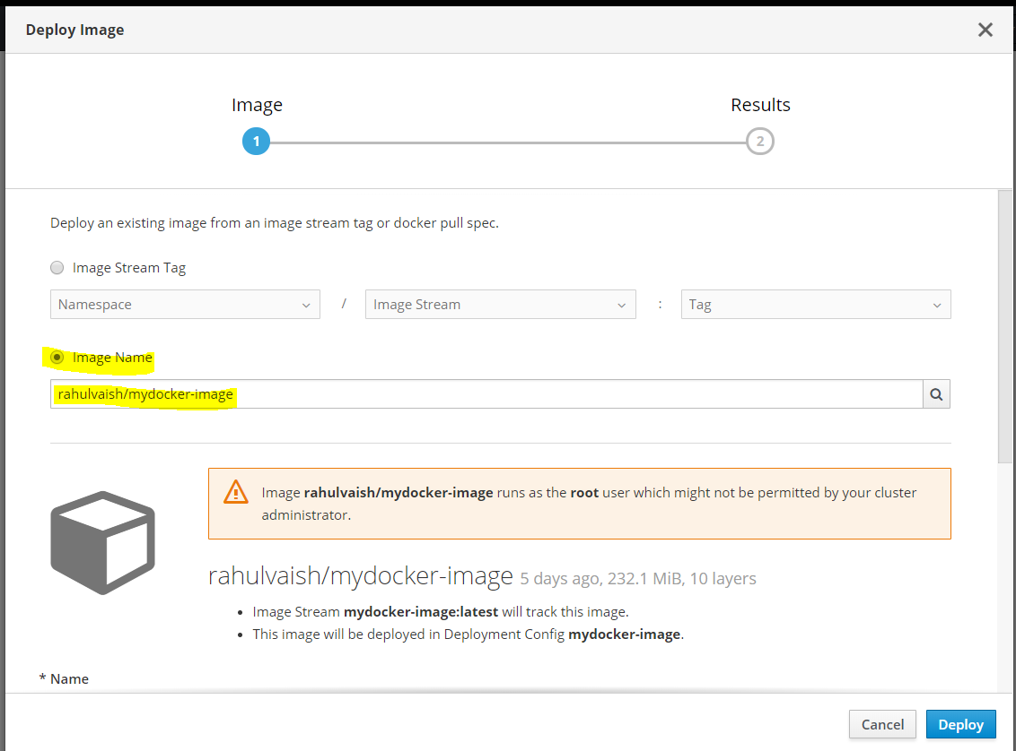

Click on deploy

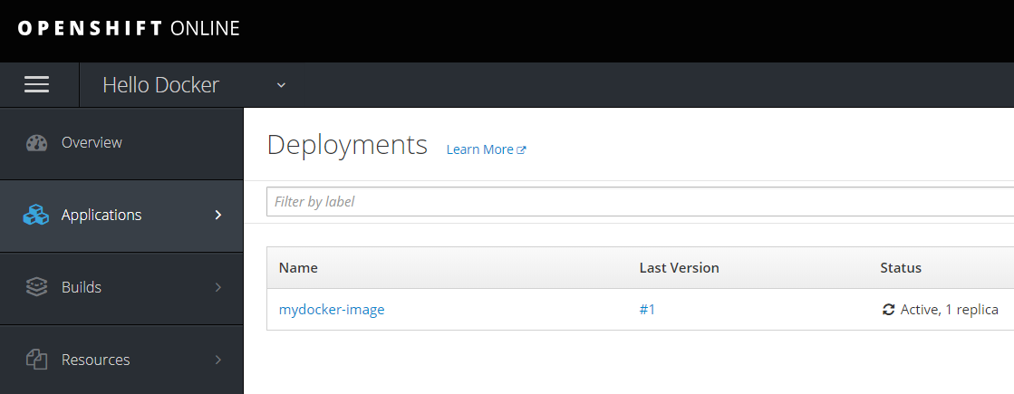

Click on #1

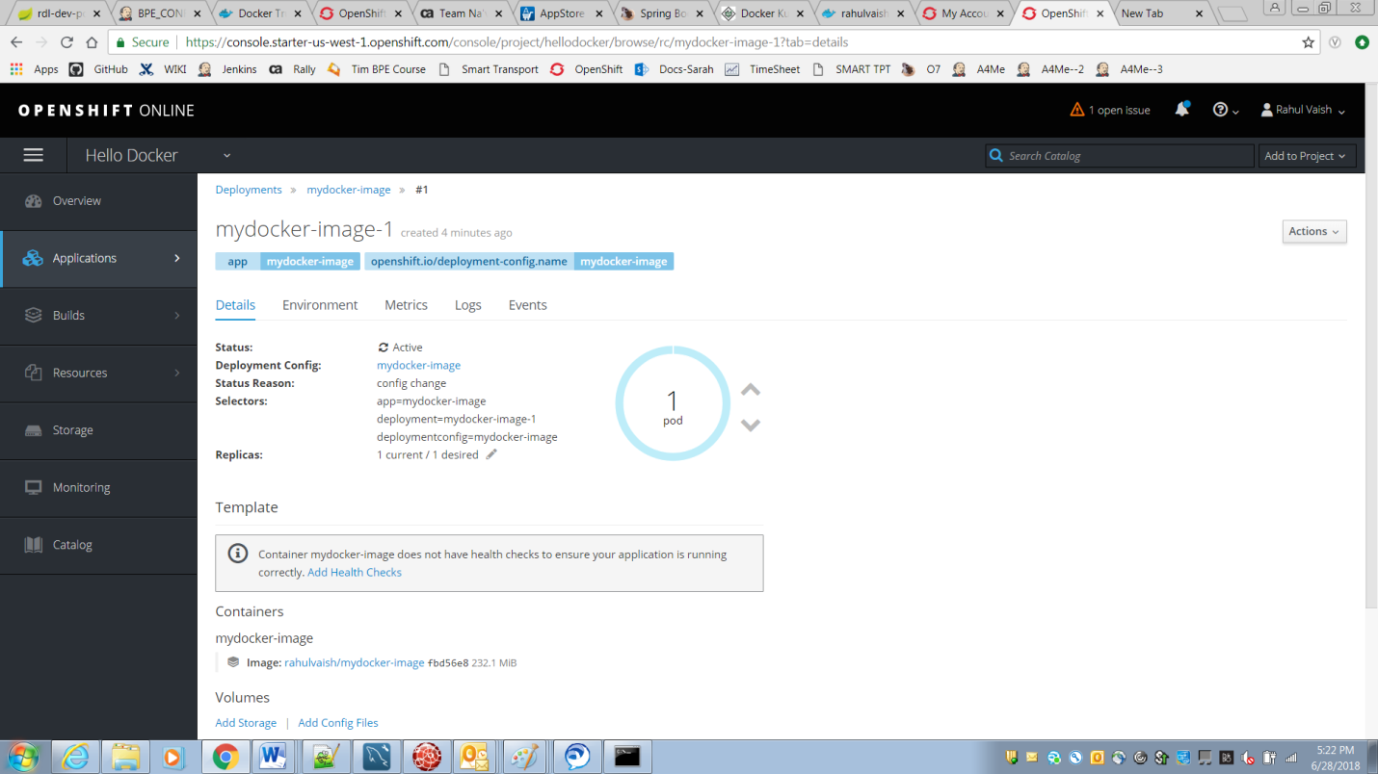

Choose ‘Logs’ Tab

